

**Unit Activity**

Unit: Trigonometry and Geometric Modeling

This Unit Activity will help you meet these educational goals:

* Mathematical Practices—You will use mathematics to model real-world situations.
* STEM—You will apply mathematical and technology tools and knowledge to grow in your understanding of mathematics as a creative human activity.

Introduction

In this activity, you will look for real-world examples of three-dimensional geometric shapes and apply geometric modeling.

**__________________________________________________________________________**

Directions and Analysis

**Task 1: Geometric Modeling**

You can often use geometric figures to model objects in the real world. You can transfer your knowledge of the properties of these figures to better understand and describe the objects that they represent.

For each shape in the table, list three examples of real-world objects that could be modeled by the shape. Use your experiences, the Internet, newspapers, magazines, or other resources to uncover examples.

**Type your response here:**

|  |  |  |  |
| --- | --- | --- | --- |
| **Shape** | **Real-World Object** | | |
| rectangular prism |  |  |  |
| triangular prism |  |  |  |
| cylinder |  |  |  |
| cone |  |  |  |
| pyramid |  |  |  |
| sphere |  |  |  |

**Task 2: Applied Modeling**

Read the story problem, and then answer the questions that follow.

Gordon works for a graphic design firm and is creating a label for a food truck vendor. The vendor specializes in finger food and wants to sell food in right conical containers so that they are easy for people to hold. To complete his label, Gordon needs to collect several different measurements to ensure that the label he designs will fit the surface of the container. Gordon has been told that the containers have a diameter of 4 inches and a height of 6 inches.



1. Find the slant height of the cone. The slant height is the distance from the apex, or tip, to the base along the cone’s lateral surface. Show your work.

**Type your response here:**

1. Find the measure of the angle formed between the base of the cone and a line segment that represents the slant height.

**Type your response here:**

1. Imagine two line segments where each represents a slant height of the cone. The segments are on opposite sides of the cone and meet at the apex. Find the angle formed between the line segments.

**Type your response here:**

**Task 3: Vectors**

A vector is a quantity that has magnitude and direction. For example, if you travel 20 miles northwest, 20 miles is the magnitude and northwest is the direction. In this example, the vector is called a displacement vector. Vectors often represent displacement, speed, acceleration, or force.

You can think about a vector as a directed line segment. The initial point is the tail of the vector. The terminal point is the tip, usually represented by an arrowhead. The vector in the diagram can be named either  or 



You can also describe a vector using component form. This form defines the vector according to the horizontal and vertical changes in the coordinates from the initial point to the terminal point. If *x* represents the horizontal change of  and *y* represents the vertical change of  then the component form of  is <*x*, *y*>. In the figure above, the horizontal change of  is 4 – 1 = 3 and the vertical change is 6 – 1 = 5. Therefore, in component form,  = <3, 5>.

1. You will now use this basic understanding of vectors to answer some questions about the magnitude of a vector. You may use the [GeoGebra](http://redirect.platoweb.com/345517) geometry tool to assist you with your answers, but using the program is not required. If you need help, follow these [instructions](http://redirect.platoweb.com/345959) for using GeoGebra.
   1. How can you find the magnitude of a vector  = <*x,* *y*>, where the horizontal change is *x* and the vertical change is *y?*

**Type your response here:**

ii. What is the magnitude of the vector  = <4, 7>?

**Type your response here:**

1. The direction of a vector is defined as the angle of the vector in relation to a horizontal line. As a standard, this angle is measured counterclockwise from the positive *x*-axis. The direction or angle of in the diagram is *α.*

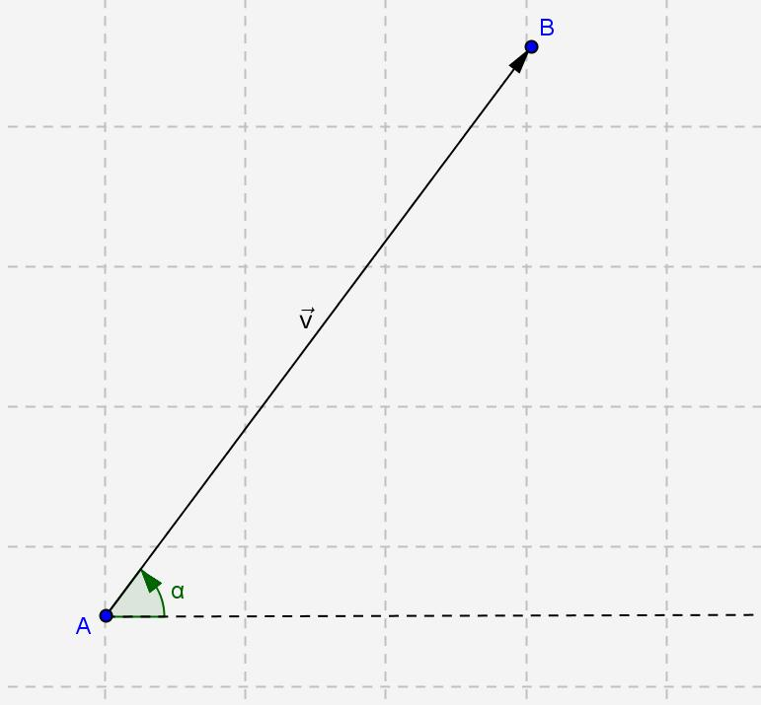

* 1. How can you use trigonometric ratios to calculate the direction *α* of a general vector  = <*x,* *y*>, similar to the diagram?

**Type your response here:**

* 1. Suppose that vector  lies in quadrant II, quadrant III, or quadrant IV. How can you use trigonometric ratios to calculate the direction (i.e., angle) of the vector in each of these quadrants with respect to the positive *x*-axis? The angle between the vector and the positive *x*-axis will be greater than 90° in each case.

**Type your response here:**

* 1. Now try a numerical problem. What is the direction of the vector  = <-1, 6>?

**Type your response here:**

1. Two vectors are said to be parallel if they point in the same direction or if they point in opposite directions.
2. Are the vectors  = <, 1> and  = < -, -1> parallel? Show your work and explain.

**Type your response here:**

1. Are the vectors  = <2, 3> and  = <-3, -2> parallel? Show your work and explain.

**Type your response here:**

**__________________________________________________________________________**

Resources

Document any references you used for this project below. At minimum, include a title and URL for any Internet resource:

**__________________________________________________________________________**

Evaluation

This project will be evaluated on a rubric that is based on the completeness, clarity, and thinking you exhibit in the Directions and Analysis section above.   
  
**Total Points: 10**

| **Task 1: Geometric Modeling** | **Task points: 2** |
| --- | --- |
| 1. Give examples of models in the real world | 2 |

| **Task 2: Applied Modeling** | **Task points: 3** |
| --- | --- |
| 1. Find the slant height of a cone 2. Find the measure of the base angle of a cone 3. Find the measure of the aperture of a cone | 1  1 |

|  |  |
| --- | --- |
| **Task 3: Vectors** | **Task points: 5** |
| 1. Find the magnitude of a vector 2. Find the direction of a vector 3. Determine whether two vectors are parallel | 1  2  2 |